**Restart Printer Remotely**

**Step 1:**

Go to “R:\Helpdesk\Script” >Right click on "RestartPrinter.bat" >Send to >Desktop (create shortcut)

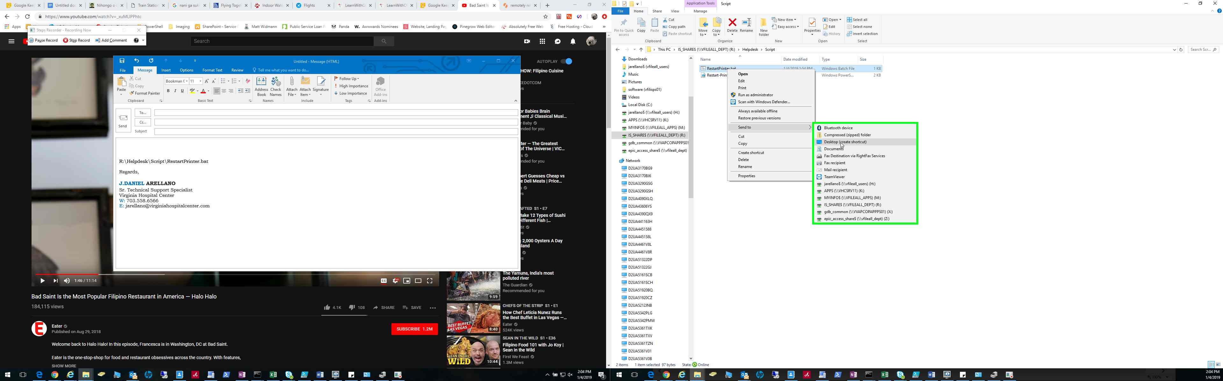

**Step 2:** Go to your Desktop and double-click the batch file “RestartPrinter.bat - Shortcut”

**Step 3:** Enter IP and press enter. To verify the printer status, go to cmd and run the command – ping “Printer IP” -t

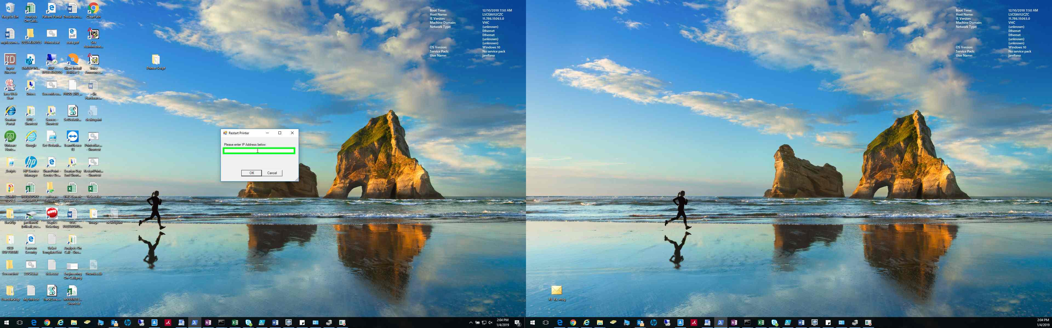

The script is located below

* R:\Helpdesk\Script\Restart-PrinterGUI.bat